My wallet application
Group ID 4
By
Students ID | Students Name | Section
442002988 | Monerah Al-mubarak | 91S
442005104 | Sarah AL-juhani | 91S
442000786 | Sarah Al-taweel | 91S
442003374 | Nada Al-otaibi | 91S

Introduction:
My Wallet application assists individuals in managing their expenses by enabling users to track their spending and create flexible budgets, helping them maintain control and achieve their financial goals. Users can monitor their expenses while planning and managing financial budgets to take control of their financial matters. My Wallet consolidates all expenses in one location, simplifying the understanding and management of users' financial data. The application leverages Machine Learning (ML) techniques to automatically classify payment categories, making the categorisation process more efficient. However, users can review and adjust the categorisation if necessary. With a wide array of features, including expense tracking, automatic categorisation, goal-setting, and timely notifications, My Wallet is designed to help users follow their budget plans.
Problem statement:
Proficient management of personal finances is essential for individuals to attain their financial targets while avoiding financial difficulties. While personal finance management applications have gained popularity, current applications have limitations, including incomplete investment tracking and currency compatibility issues.
Furthermore, some applications lack essential features such as categorising expenses or setting notifications for upcoming bills and have complicated user interfaces that make them difficult to use. To overcome these limitations, the proposed personal finance management application will provide comprehensive features with a user-friendly interface incorporating machine learning algorithms to offer personalised insights and recommendations. These algorithms will include automatic expense categorisation and customised investment suggestions based on the user's financial goals and risk tolerance. The application will allow users to easily track their expenses, income, and savings, offer investment tracking capabilities, and be compatible with multiple currencies.
Additionally, the application will include customisable notifications for upcoming bills and report generation features.[1]
Project objectives:
- Comprehensive income and expense tracking: Enable users to efficiently manage transactions, access them promptly, and apply filters based on specific periods.
- Expense categorisation: Empower users with the ability to categorise their expenses for improved comprehension and effective budget management.
- Customisable notifications: Alert users about upcoming payments, rising expenditures, or any missed updates to financial information.
- Goal-setting capabilities: Allow users to establish and work towards financial targets, such as saving $100 per week.
- Enhanced security: Strengthen the application's security measures to protect user data better.
- Improved efficiency and user experience: Optimise the application to be more efficient, user-friendly, and intuitive.

- Streamlined data management: Simplify data input and interpretation for users, making it easy to manage and comprehend their financial information.
- Focus on customer satisfaction: Prioritise user needs and preferences to ensure high satisfaction with the application.
Methodology:
The most appropriate SDLC model for this project is the iterative model, as it does not require a complete specification of requirements from the start.
Instead, the software is developed by specifying and implementing a part of it as quickly as possible, then reviewing and identifying further requirements. This process is repeated for each iteration of the model, incorporating customer feedback to develop subsequent versions.
The iterative model enables easier risk management by identifying and addressing risky components and allows for more cost-effective changes in scope and requirements.[2]
Project Requirements :
Software Requirements:
- Operating System: The application should be compatible with popular mobile operating systems such as Android and iOS.
- Programming Language: Use programming languages such as Java or Kotlin for Android development and Swift for iOS development.
- Development Framework: Utilize frameworks like Android Studio with Android SDK for Android development and Xcode with iOS SDK for iOS development.
- Database: Implement a local database or use a remote database solution like Firebase or SQLite to store and manage user data securely.
- Machine Learning Libraries: Incorporate machine learning libraries suitable for mobile platforms, such as TensorFlow Lite or Core ML, to support automatic expense categorization and personalized recommendations.
- Notification Service: Integrate the platform-specific notification service (e.g., Firebase Cloud Messaging for Android, Apple Push Notification Service for iOS) to send custom notifications to users.

Hardware Requirements:
- Processor: The application should be compatible with a wide range of mobile processors, including ARM and x86 architectures.
- Memory: The application should operate smoothly with at least 2GB of RAM on the device.
- Storage: The application should require a reasonable amount of storage space on the device for installation and data storage.

Functional Requirements:
- User Registration: Allow users to create an account, sign in securely, and manage their profile information.
- Expense Tracking: Enable users to add, edit, and delete their expenses, recording details such as date, category, amount, and notes.
- Expense Categorization: Implement automatic expense categorization using machine learning algorithms and provide the ability for users to review and adjust categorization if needed.
- Budget Management: Allow users to set budgets for different expense categories and track their spending against those budgets. Provide visual representations like charts or graphs to visualize budget progress.
- Notifications: Enable users to set customizable notifications for upcoming bills, spending limits, or other financial reminders.
- Goal Setting: Allow users to set financial goals, such as saving a specific amount per week or achieving a certain investment target, and track their progress.
- Investment Tracking: Enable users to track their investments, including stocks, mutual funds, or other financial instruments. Display current values, gains/losses, and historical performance.
- Multi-Currency Support: Ensure the application supports multiple currencies, allowing users to enter expenses, income, and investments in different currencies, with automatic currency conversion if necessary.
- Reporting and Analytics: Generate comprehensive reports and provide data analytics features to help users gain insights into their financial habits, expenses, and savings over time.
- Security: Implement appropriate security measures, such as data encryption, secure authentication, and secure communication protocols, to protect user data and ensure privacy.
- User Interface: Design an intuitive and user-friendly interface optimized for mobile devices, ensuring easy navigation, readability, and a seamless user experience.

Scope Statement:

Project Name | My Wallet
Date Start | May 30, 2023
Date Finish | August 13, 2023
Project Description | Develop a comprehensive personal finance management application that helps users track expenses, manage budgets, set goals, and receive personalized recommendations. The application will have a user-friendly interface, machine learning algorithms for automatic expense categorization, and enhanced security features.
Project User Acceptance Criteria | Users can efficiently track income and expenses, categorize transactions, set financial goals, receive notifications, view reports, and access comprehensive analytics. The application has an intuitive user interface, supports multiple currencies, ensures data security through encryption and secure authentication, and integrates with third-party services. User feedback indicates high satisfaction with the application's features, performance, and security.
Project Deliverables | 1. My Wallet Mobile Application for Android and iOS  2. Backend API and Database  3. Machine Learning Models for Expense Categorization and Personalized Recommendations  4. User Documentation  5. Deployment on App Stores
Constraints | 1. Budget constraint: Limited budget for development  2. Time constraint: The application must be completed within six months  3. Technical constraint: Compatibility with popular mobile operating systems (Android and iOS) and support for multiple currencies  4. Availability of necessary APIs and machine learning libraries
Assumptions | 1. Skilled development team members  2. Adequate resources (hardware, software, and personnel) for project completion  3. User adoption and engagement with the application  4. Ongoing support and maintenance costs within the allocated budget

Work Breakdown Structure :[3]

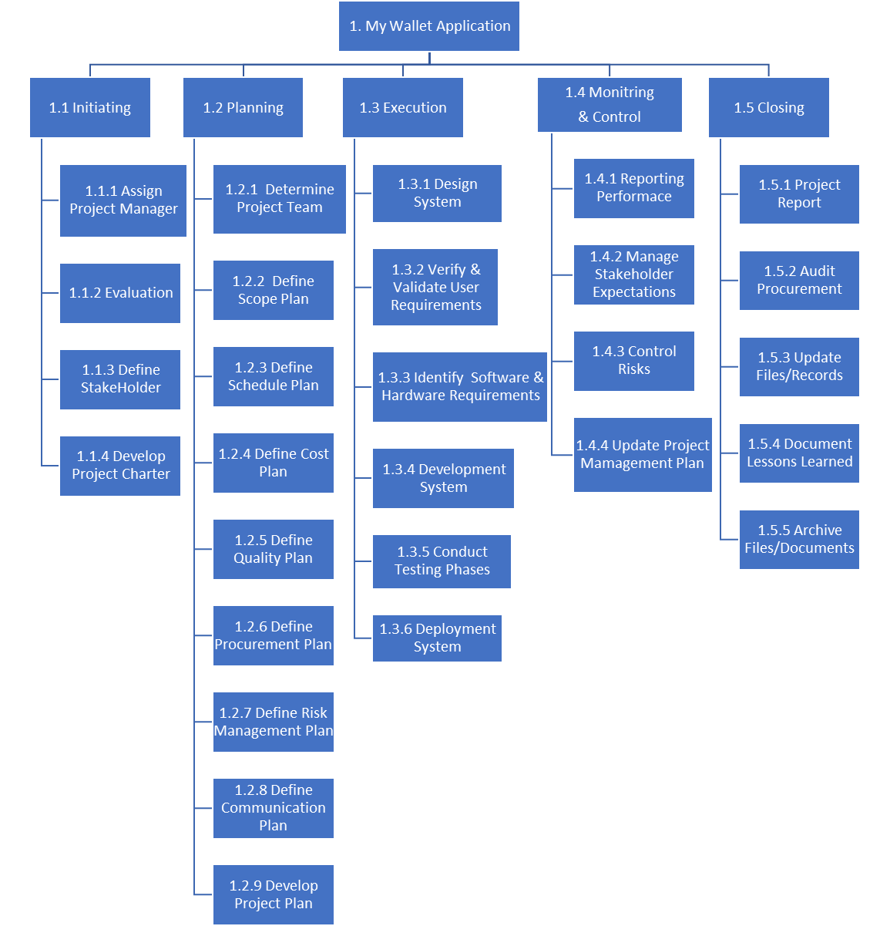

1. My wallet application Project
1.1 Initiating
1.1.1 Assign Project Manager
1.1.2 Evaluation
1.1.3 Define Stakeholders
1.1.4 Develop Project Charter
1.2 Planning
1.2.1 Determine Project Team
1.2.2 Define Scope Plan
1.2.3 Develop Project Plan
1.2.4 Define Schedule Plan
1.2.5 Define Cost Plan
1.2.6 Define Quality Plan
1.2.7 Define Procurement Plan
1.2.8 Define Risk Management Plan
1.2.9 Define Communication Plan
1.3 Execution
1.3.1 Design System
1.3.2 Verify & Validate User Requirements
1.3.3 Identify Software & Hardware Requirements
1.3.4 Develop System
1.3.5 Conduct Testing Phases
1.36. Deployment System
1.4 Monitoring & Control

1.4.1 Reporting Performance
1.4.2 Address Bug Fixes and Enhancements
1.4.3 Control Risks
1.4.4 Update Project Management Plan
1.4.5 Manage Stakeholder Expectations
1.5 Closing
1.5.1 Project Report
1.5.2 Audit Procurement
1.5.3 Update Files/Records
1.5.4 Document Lessons Learned
1.5.5 Archive Files/Documents
WBS Dictionary:
Level | WBS Code | Element Name | Definition
1 | 1 | My wallet application | My Wallet Application Develop a personal finance management application that helps users track expenses, manage budgets, set goals, and receive personalized recommendations with a user-friendly interface, machine learning algorithms, and enhanced security features.
2 | 1.1 | Initiating | The work to initiate the application
3 | 1.1.1 | Assign Project Manager | The appropriate project manager is chosen.
3 | 1.1.2 | Evaluation | A working group assesses the sets of solutions.
3 | 1.1.3 | Define Stakeholders | Identify the individuals who will be a part of the project and those who are going to be affected by it.
3 | 1.1.4 | Develop Project Charter | A document is created by the project manager to officially authorize the start of work on a project.
2 | 1.2 | Planning | Plan out all of the steps that must be taken to construct the My Wallet application project.
3 | 1.2.1 | Determine Project Team | The right workers for the project are chosen by the project manager.
3 | 1.2.2 | Define Scope Plan | Define the work that needs to be done.
3 | 1.2.3 | Develop Project Plan | The team develops the project plan with the project manager's assistance.
3 | 1.2.4 | Define Schedule Plan | Schedule activities related to the work.
3 | 1.2.5 | Define Cost Plan | Calculate the estimated price of the work and establish a budget.
3 | 1.2.6 | Define Quality Plan | Ensure the product complies with the stated specifications and intended usage.
3 | 1.2.7 | Define Procurement Plan | Select the resources that will be needed to complete the task.
3 | 1.2.8 | Define Risk Management Plan | Create a plan to identify, assess, and mitigate risks during My Wallet application development, ensuring proactive risk management.
3 | 1.2.9 | Define Communication Plan | Create a communication strategy and plan for effective project information sharing, stakeholder engagement, and project meetings/reports.
2 | 1.3 | Execution | A process that executes several plans and produces the My Wallet application.
3 | 1.3.1 | Design System | Develop application design, including user interfaces.
3 | 1.3.2 | Verify & Validate User Requirements | The project manager and team examine and confirm with the stakeholders the user's needs.
3 | 1.3.3 | Identify Software & Hardware Requirements | Determine necessary software and hardware components for the My Wallet application, ensuring compatibility and performance.
3 | 1.3.4 | Develop System | Build the application system based on requirements, design, and coding standards.
3 | 1.3.5 | Conduct Testing Phases | Perform testing activities to ensure quality, functionality, and usability of the My Wallet application.
3 | 1.3.6 | Deployment System | Deploy My Wallet application, install and configure the application in the designated environment for smooth end-user setup.
2 | 1.4 | Monitoring & Control | Monitor and control the progress of the My Wallet application project.
3 | 1.4.1 | Reporting Performance | Collect and analyse project data to generate performance reports and track progress against the plan.
3 | 1.4.2 | Address Bug Fixes and Enhancements | Identify and resolve reported bugs and issues for continuous improvement of the My Wallet application.
3 | 1.4.3 | Control Risks | Monitor and manage project risks, implementing response plans to minimize their impact.
3 | 1.4.4 | Update Project Management Plan | Revise and update the project plan to reflect changes during execution.
3 | 1.4.5 | Manage Stakeholder Expectations | Engage stakeholders, communicate updates, and address concerns during My Wallet application development.
2 | 1.5 | Closing | Finalize the My Wallet application project.
3 | 1.5.1 | Project Report | Create a comprehensive report summarizing project details, including objectives, achievements, challenges, and recommendations for future projects.
3 | 1.5.2 | Audit Procurement | Conduct a procurement audit to ensure compliance with policies and procedures.
3 | 1.5.3 | Update Files/Records | Update project documentation and files for future reference and archival purposes.
3 | 1.5.4 | Document Lessons Learned | Capture and document project insights, including successes, challenges, and areas for improvement, to enhance future project performance.
3 | 1.5.5 | Archive Files/Documents | Archive and store project files, documents, and records in a secure and organized manner.

RACI Chart: [4]

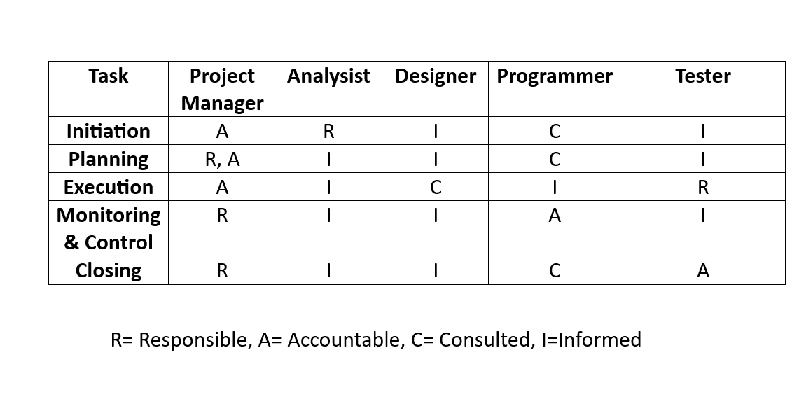
Gantt Chart:
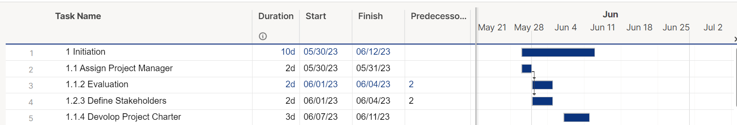
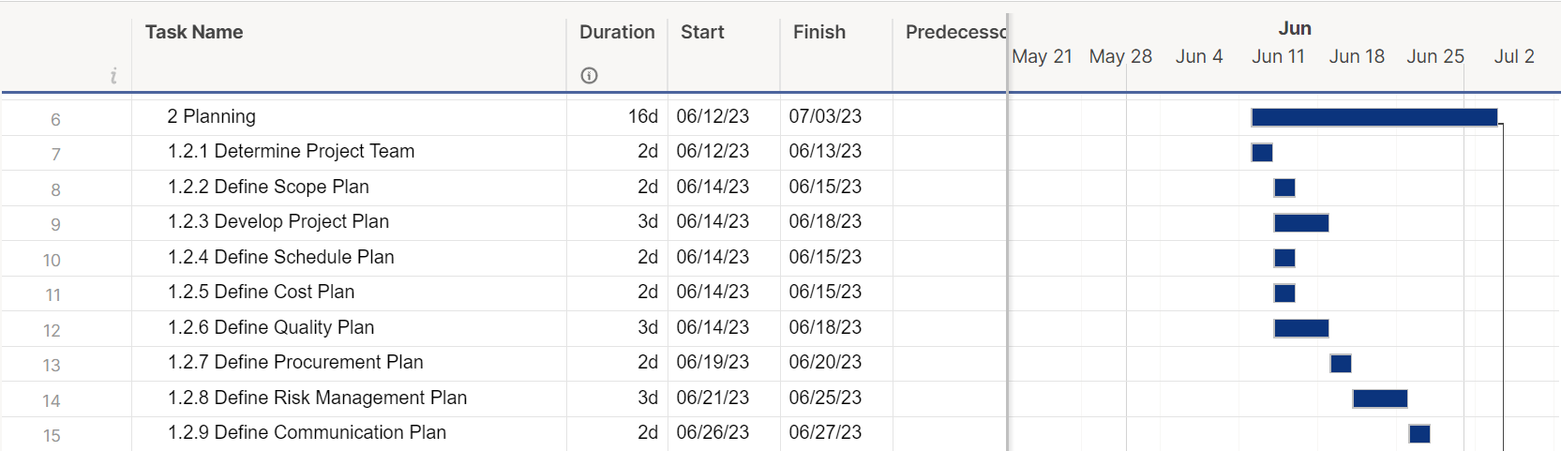
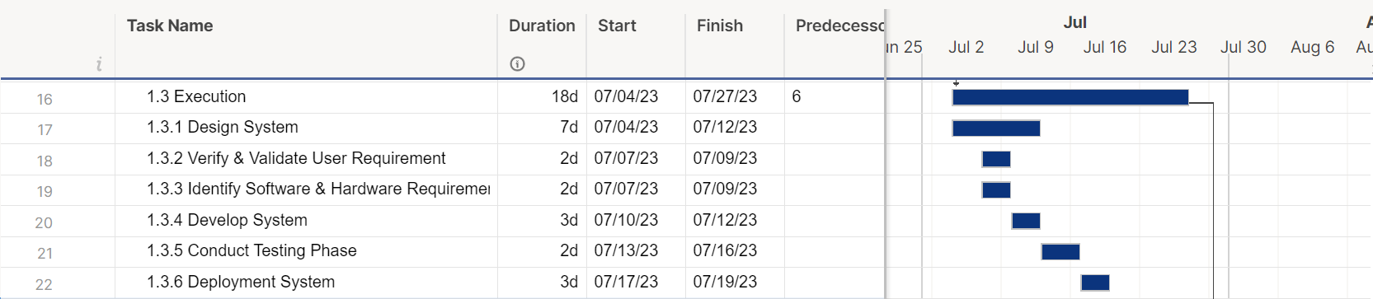
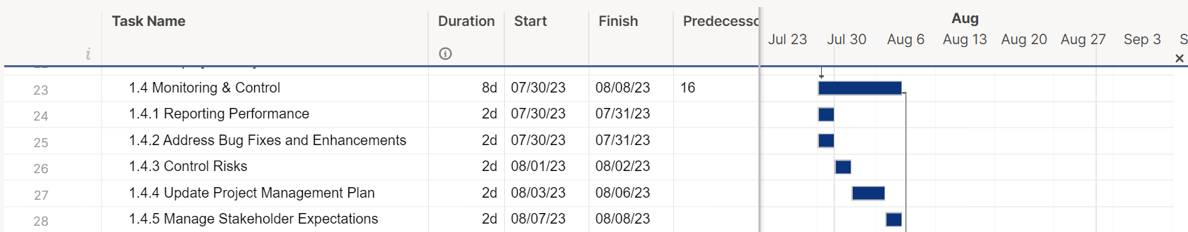

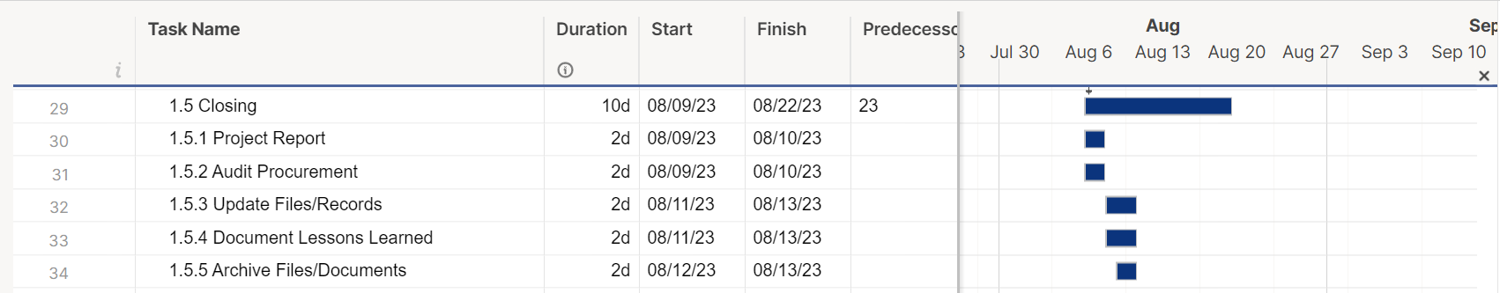

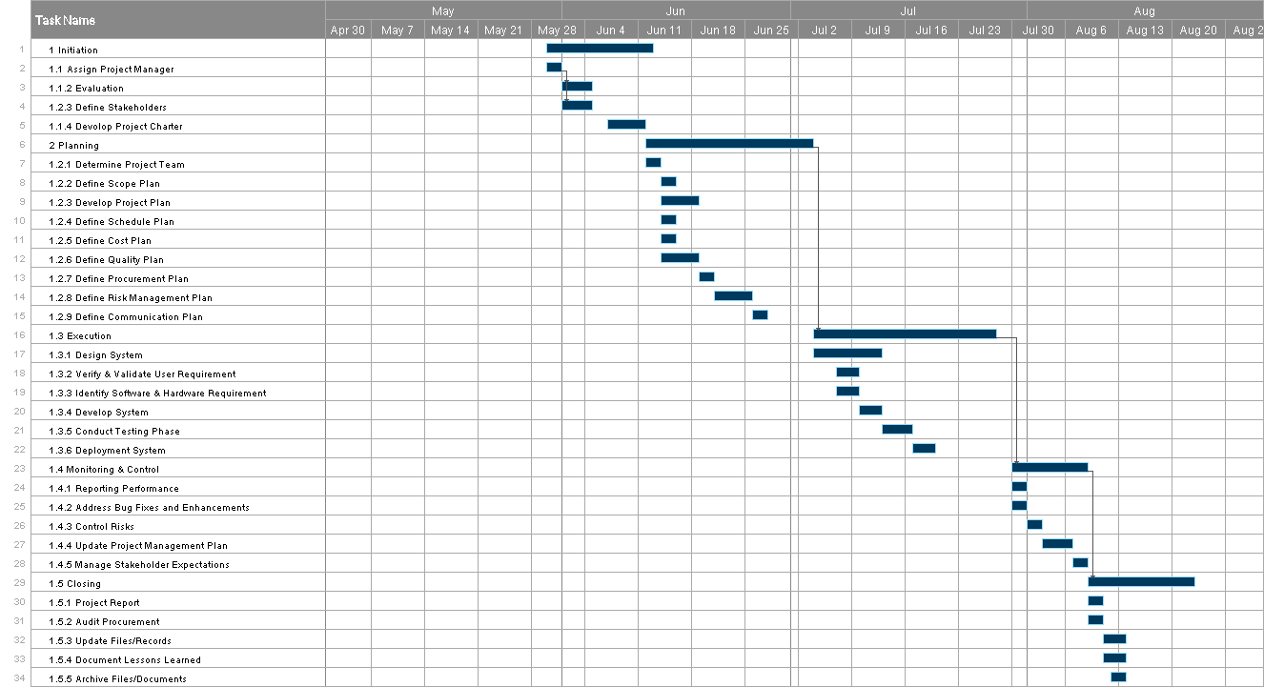

References

[1] | Kazakevich, “AI and ML in Financial Planning Apps: Applications, Cost, and Case Studies,” 2019. [Online]. Available: https://hqsoftwarelab.com/blog/ai-and-ml-in-financial-planning-apps/#applications.
[2] | “Iterative Model: Advantages, Disadvantages, and When to Use it,,” [Online]. Available: https://www.professionalqa.com/iterative-model..
[3] | “Work Breakdown Structure,” [Online]. Available: https://www.workbreakdownstructure.com/.
[4] | “smartsheet,” [Online]. Available: https://www.smartsheet.com/.

